Personality Prayers

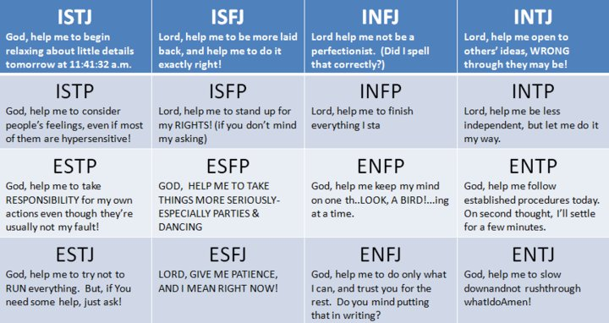

From: http://borntoexplore.org/prayers.htm

